|  |  |
| --- | --- |
| Lab 4 | |
| ECE 380 W21 | |
| Group 8 | |
| Arjun Bawa, a3bawa | Andrew Tran, a89tran |

Table of Contents

Declaration of Authorship 3

4.1 4

4.2 4

4.3 4

4.4 5

4.5 5

4.6 7

4.7 7

4.8 8

1 8

2 9

3 10

4 11

5 11

6 12

7 12

# Declaration of Authorship

We acknowledge and promise that:

1. We are the sole authors of this lab report and associated simulation files/code.
2. This work represents our original work.
3. We have not shared detailed analysis or detailed design results, computer code, or Simulink diagrams with any other student.
4. We have not obtained or looked at lab reports from any other current or former student of ECE/SE 380, and we have not let any other student access any part of our lab work.
5. We have completely and unambiguously acknowledged and referenced all persons and aids used to help us with our work.

|  |  |
| --- | --- |
| Student1 Name and Signature:  **Arjun Bawa** | Student2 Name and Signature:  **Andrew Tran** |

# 4.1

Choose

# 4.2

Choose

# 4.3

# 4.4

# 4.5

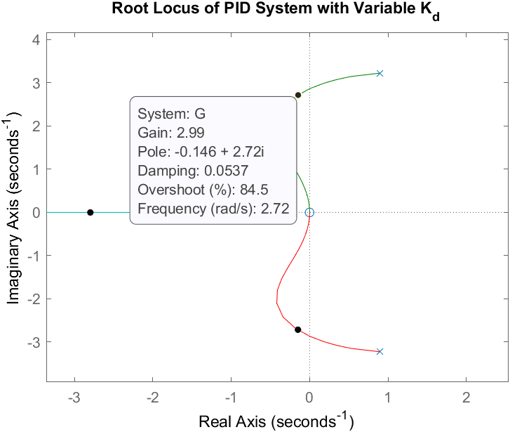

# 4.6

Increase from to to reduce overshoot.

# 4.7

# 4.8

## 1

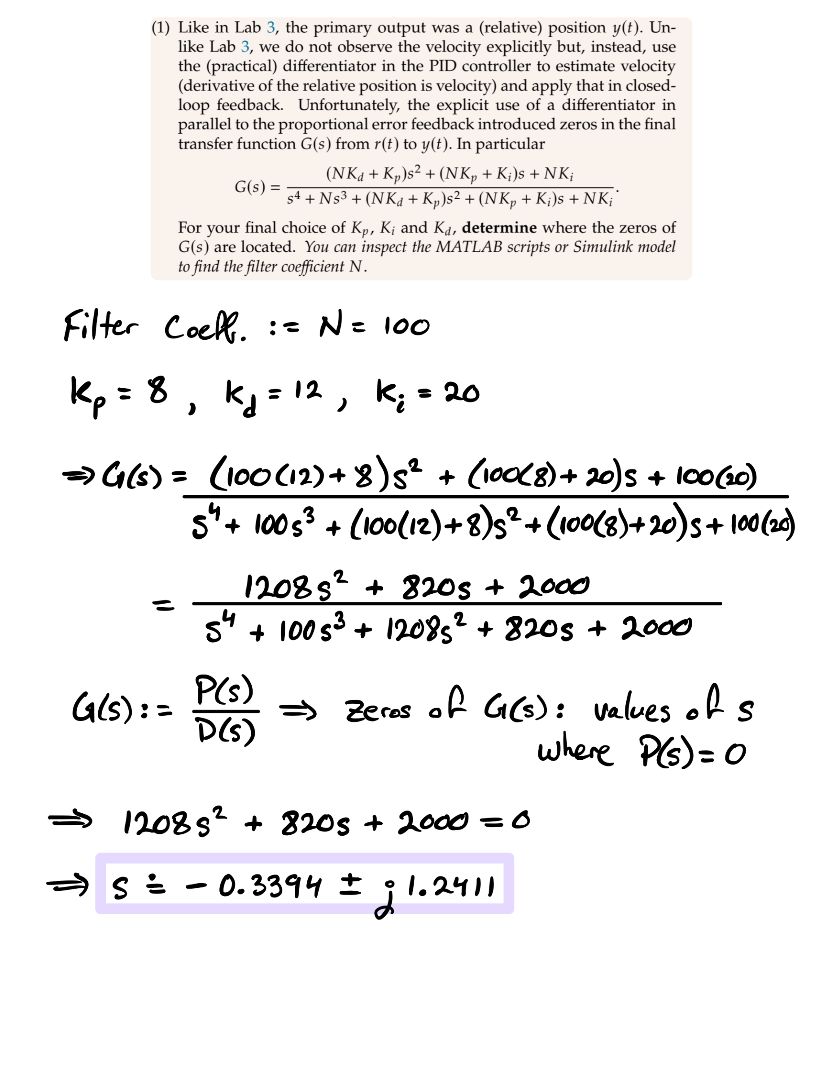

## 2

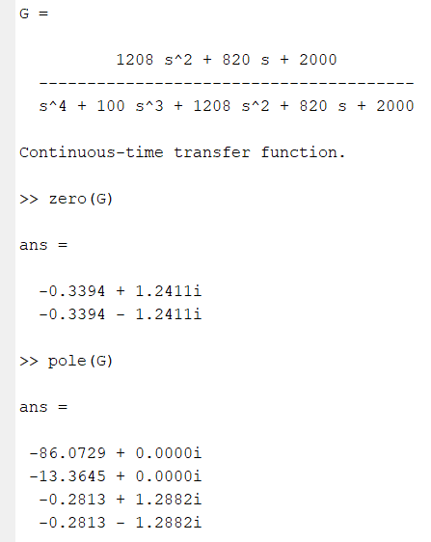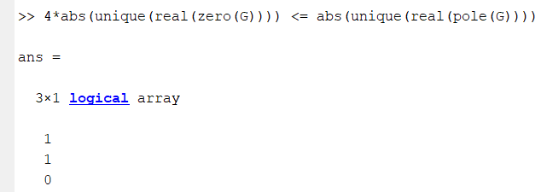

Therefore, zeros affect system’s response.

|  |  |
| --- | --- |
| Chart, line chart  Description automatically generated  Step response for | Chart, line chart  Description automatically generated  Step response for |

We see that the zeros had a dampening effect on the step response of the system, dramatically reducing overshoot and settling time.

Observing 4.7, we see the zeros affected the response drastically until the 15 second mark. The zeros dampened the response relative to the response of , to the point of causing undershoot at .

## 3

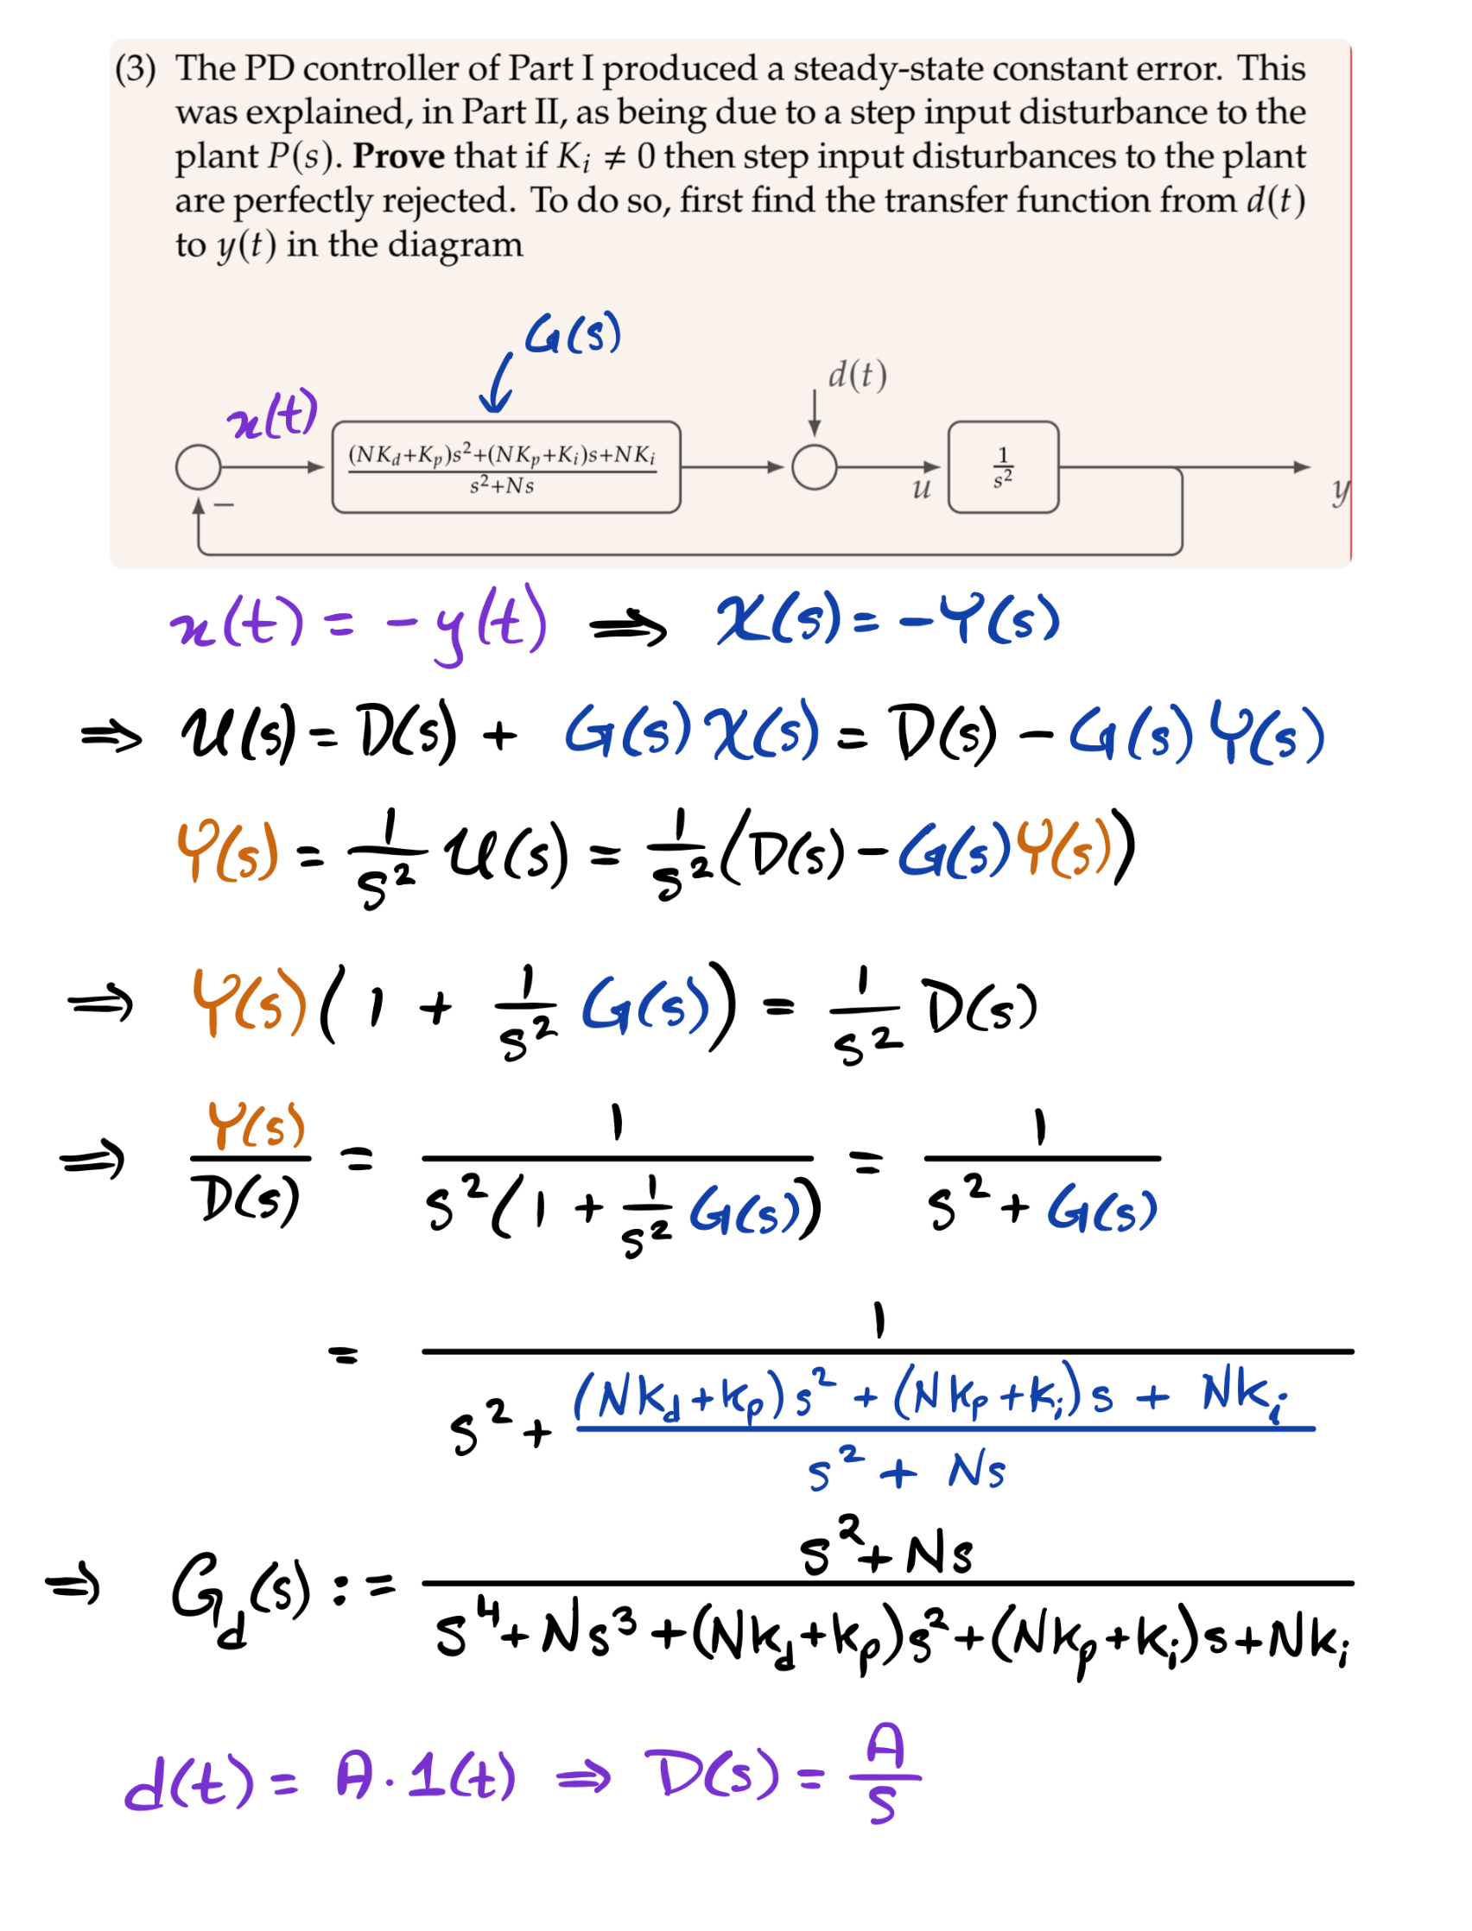

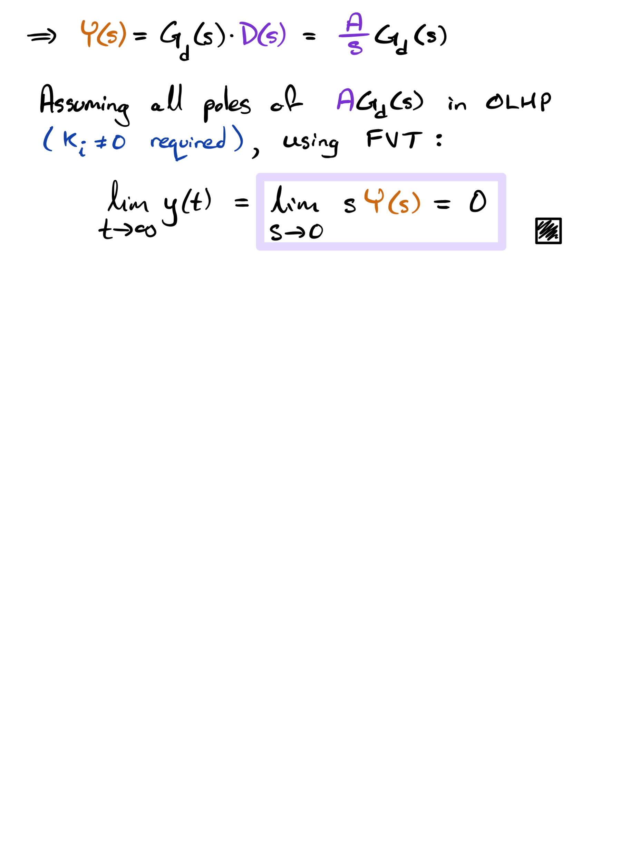

## 4

Increasing generally results in decrease of settling time. An increase in generally corresponds with an increase in from the origin to each pole, creating an increase in overshoot. An increase in also corresponds to a decrease in rise time and peak time.

Increasing generally results in decrease of settling time. An increase in generally corresponds with a decrease in from the origin to each pole, creating a decrease in overshoot. An increase in also corresponds to a decrease in rise time and peak time.

Increasing (up till its upper limit) generally results in decrease of settling time. An increase in generally corresponds with an increase in from the origin to each pole, creating a decrease in overshoot. An increase in also corresponds to a decrease in rise time and peak time.

## 5

From the proof in part 3, we know that an integrator term creates perfect rejection of any type of step-input disturbances. When analyzing a system with , a constant error cannot be mitigated by the controller, meaning a steady-state error can’t be fixed. When the integrator term is included (i.e. ), the time a constant error *persists* is accounted for when error-correcting. This means over time, the integrator will get rid of constant error that persists, leading to no steady-state error by step-input disturbance.

The trade-off of the inclusion of the integrator term is that it makes the system more “sluggish” by increasing overshoot and settling time.

## 6

This change would not change the answer in a significant way other than there being no poles at with this plant. A pole would need to be added at for steady-state error tracking.

## 7

We aimed to improve overshoot by increasing . The reason was chosen to increase was simply that it had the best benefits-to-drawbacks ratio out of all the possible changes to any of the gains. Increasing not only reduced significant overshoot, but improved rise time as well without increasing settling time. An increase in causes a decrease in from the origin, decreasing overshoot.